Lab 6

Natnael Kebede

**Section 1**

1. Screen capture showing the scheduled backup configuration and the system clock

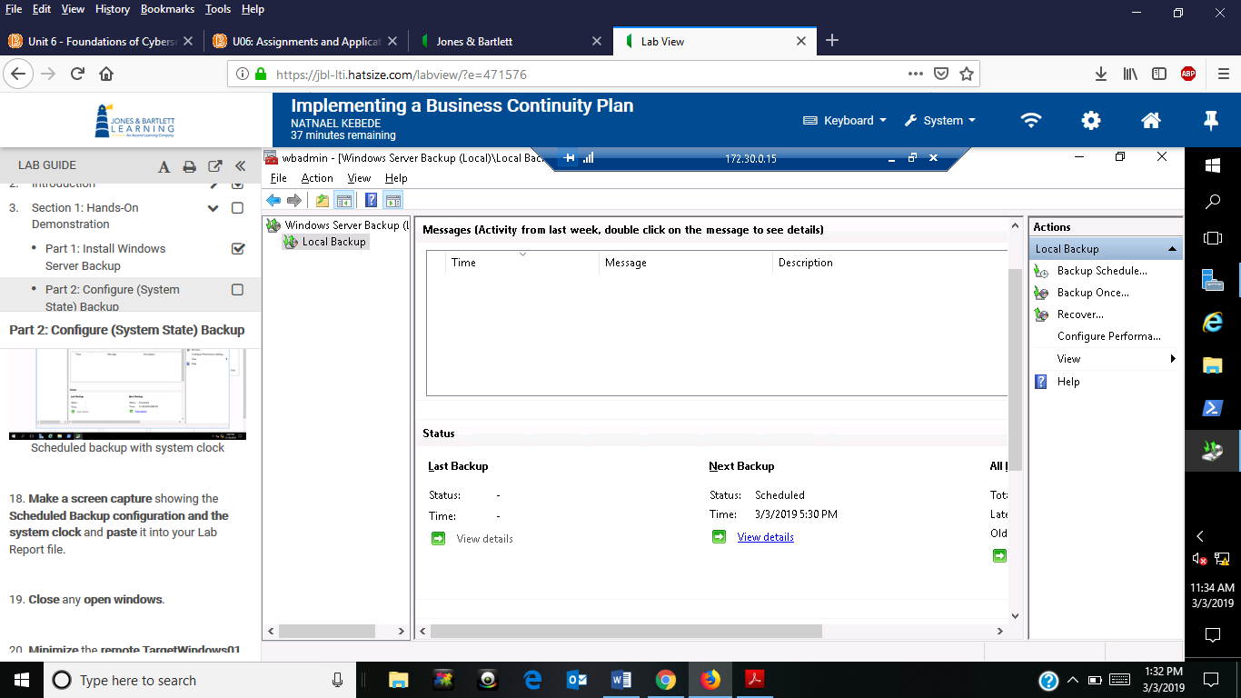

1. Screen capture showing the updated website content for www1 site

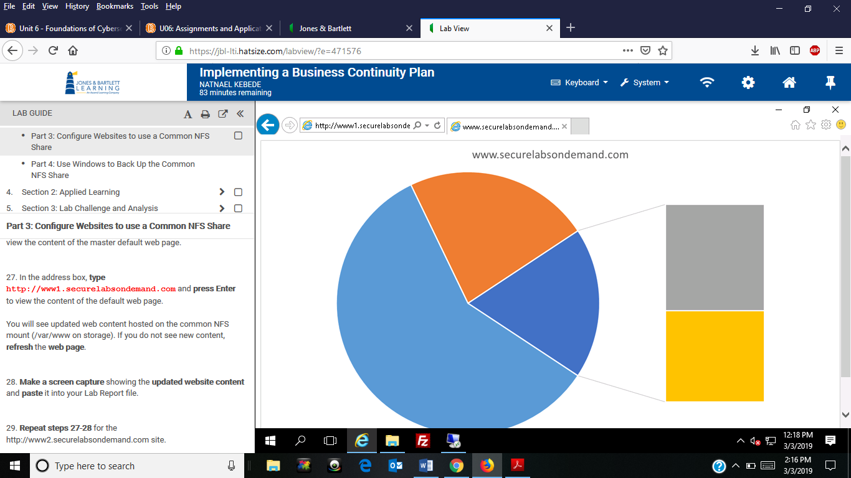

1. Screen capture showing the updated website content for www2 site

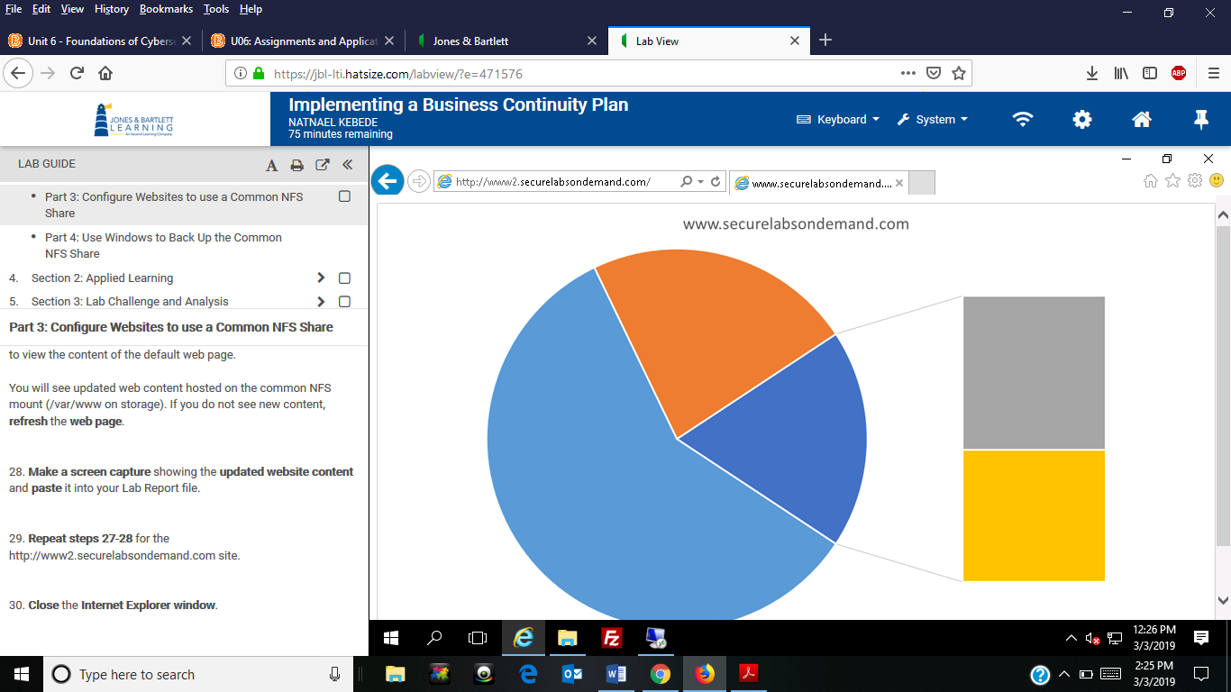

1. Screen capture showing the contents of the Z directory

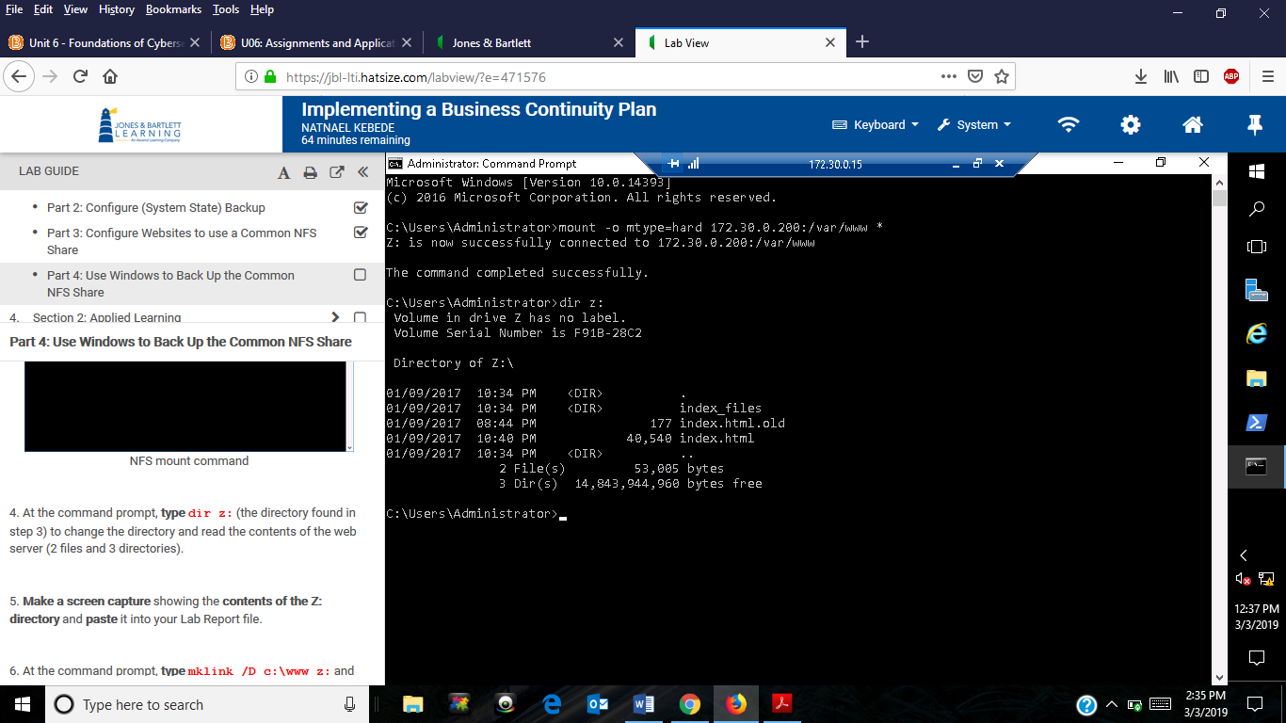

1. Screen capture showing the contents of the www directory after using the mklink command

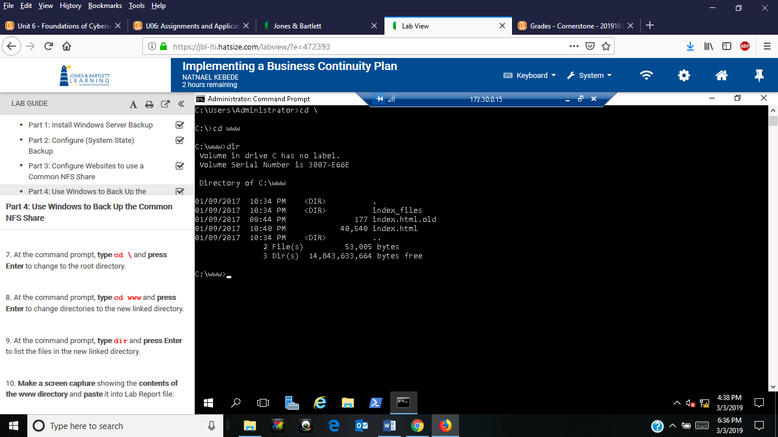

1. Screen capture showing the contents of the c:\backup directory

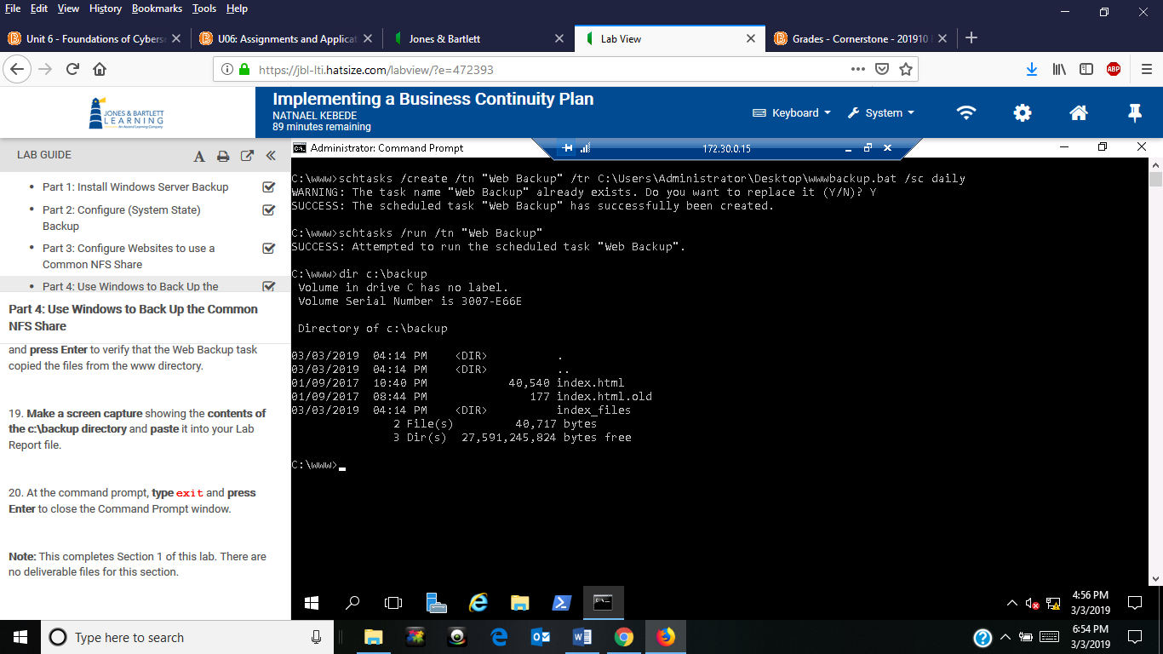

**Section 2**

1. Screen capture showing the scheduled backup setting in PowerShell

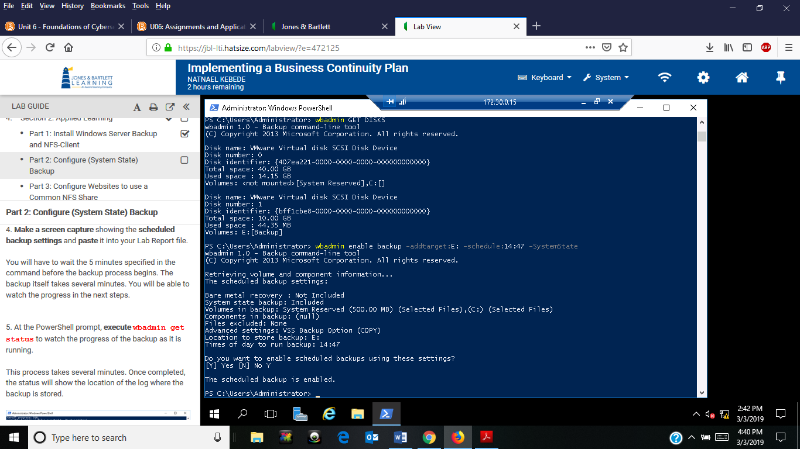

1. Screen capture showing the www1 filesystem mount point

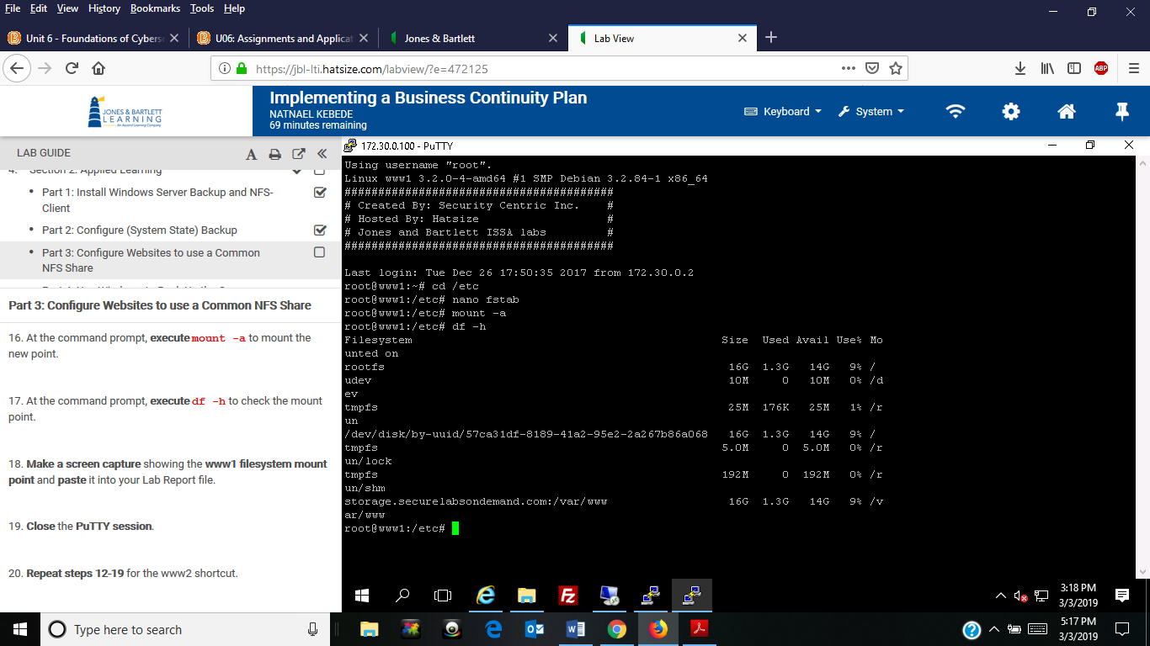

1. Screen capture showing the www2 filesystem mount point

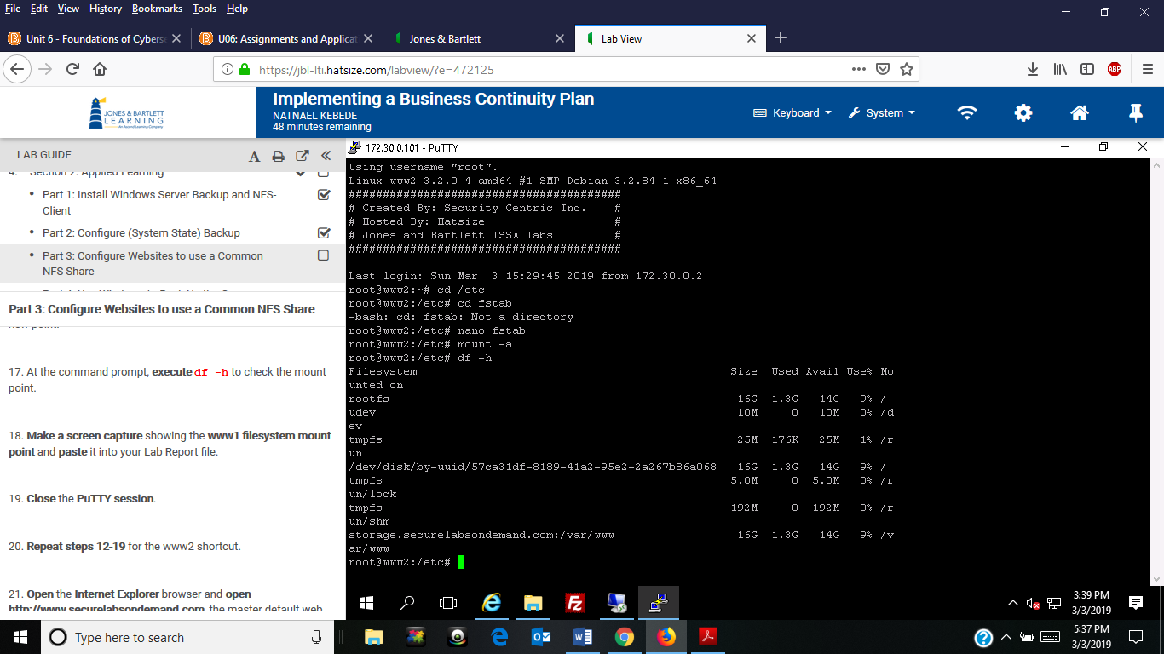

1. Screen capture showing the symbolic link for c:\www

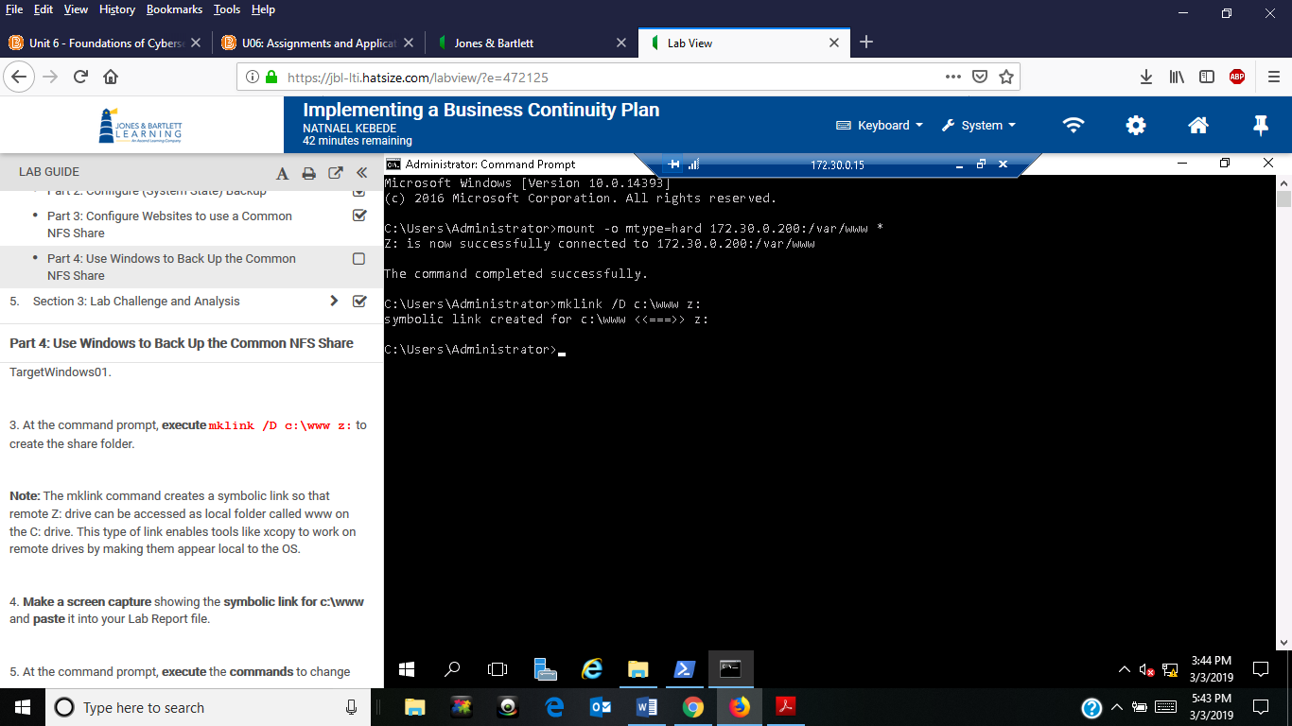

1. Screen capture showing the contents of the c:\www directory

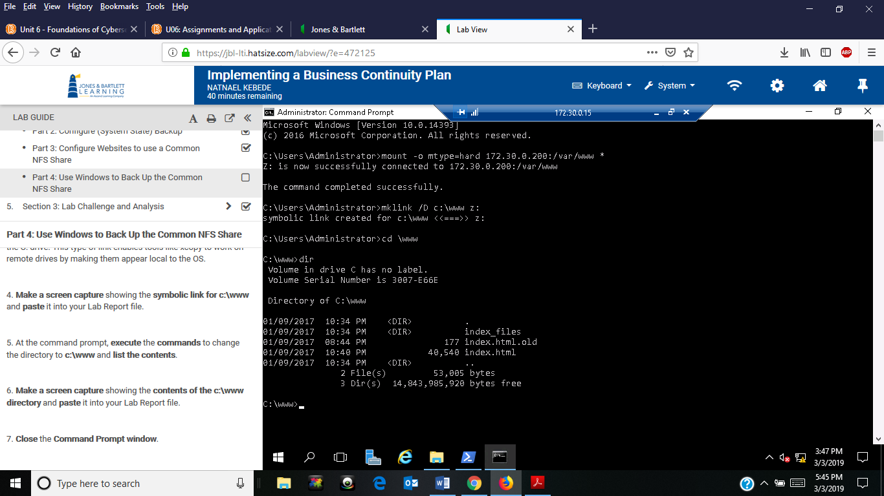

1. Screen capture showing the contents of the c:\backup directory

